School Name
Mathematics Test 2017
Year 8 |  | Percentages and Financial Maths | Non Calculator  Section
Skills and Knowledge Assessed:  - Connect fractions, decimals and percentages and carry out simple conversions (ACMNA157)  - Find percentages of quantities and express one quantity as a percentage of another, with and without digital technologies (ACMNA158)  - Solve problems involving the use of percentages, including percentage increases and decreases, with and without digital technologies (ACMNA187)  - Investigate and calculate Goods and Services Tax (GST), with and without digital technologies  - Investigate and calculate ‘best buys’, with and without digital technologies (ACMNA174)  - Solve problems involving profit and loss, with and without digital technologies (ACMNA189) |  |  | Name___________________
Answer all questions in the spaces provided on this test paper by:
Writing the answer in the box provided.
or
Shading in the bubble for the correct answer from the four choices provided.
Show any working out on the test paper. Calculators are not allowed.
 | Write 18.5% as a decimal number.
 | Convert the fraction 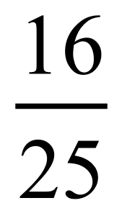 to a percentage.
 | Write 45% as a fraction in simplest form.
 | 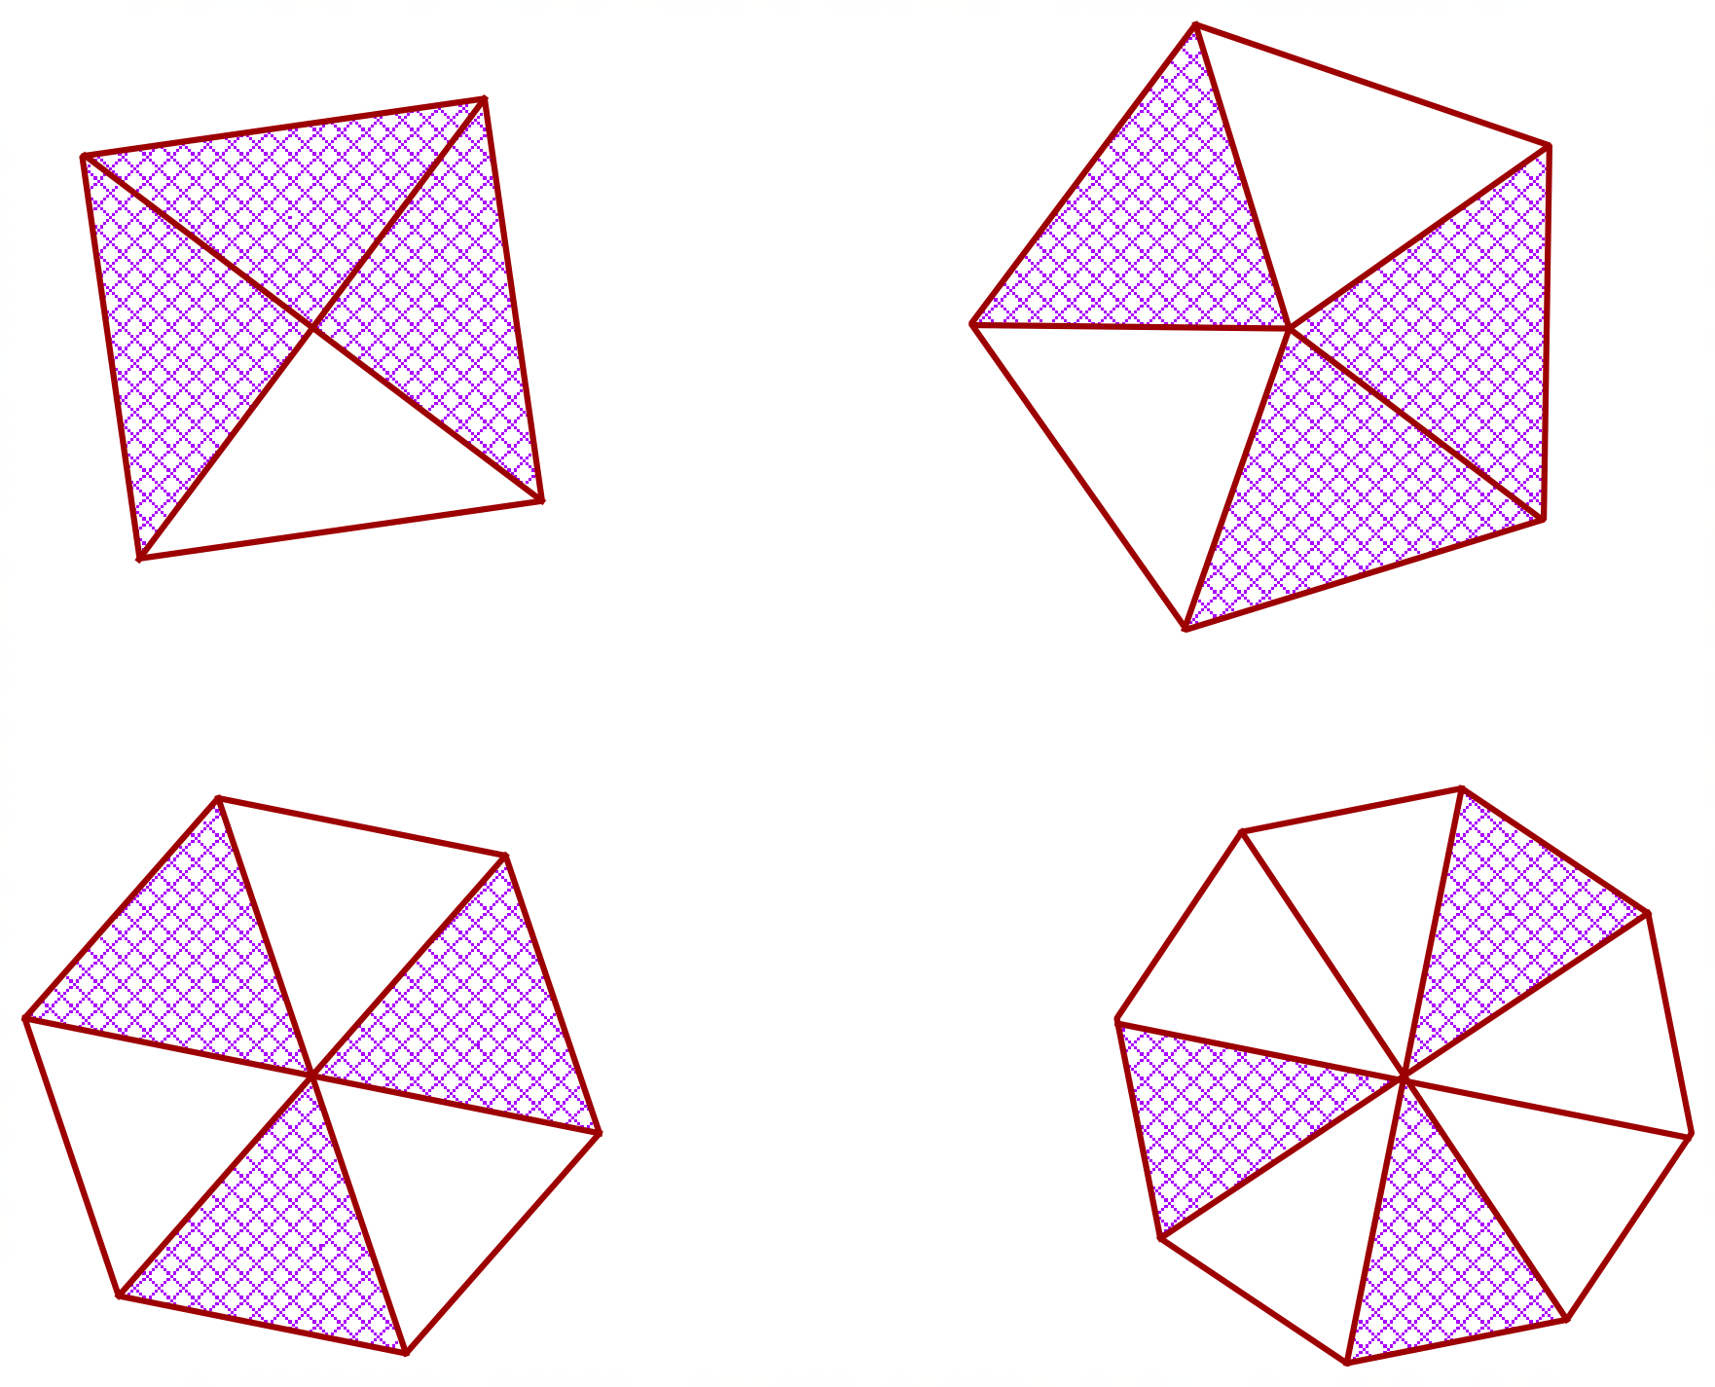Which diagram has 0.6 of the polygon shaded?
What is 35% of 80 kg?

28 kg 35 kg 42 kg 140 kg
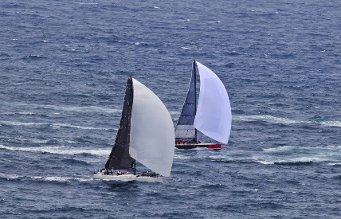
A yacht race had 120 starters.
Due to a storm 40% of the yachts did not finish the race.
How many yachts did not finish the race?

Josie pays 32% of her wage to her parents in board.
Her wage is $125 per week.
How much does she pay to her parents?

$32 $35 $40 $42
Jacqui makes 120 cupcakes of which 48 are chocolate and the rest are vanilla.
What percentage of the cupcakes are chocolate?

Which fraction is equivalent to 84% ?

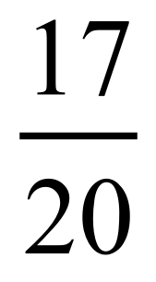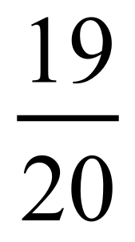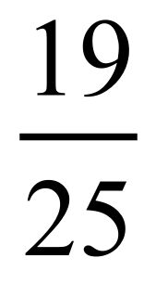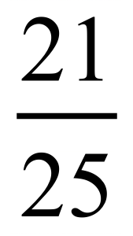
 | Write the decimal 0.375 as a percentage.
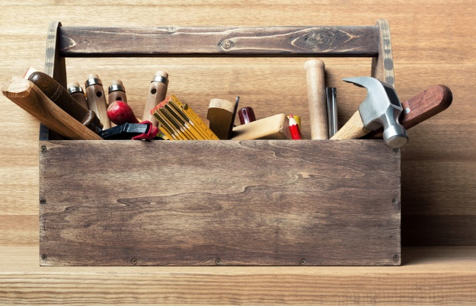
Justin has four types of tools in his toolbox.
7.5% of the tools are hammers, 10% are wrenches, 45% are spanners and the rest are screwdrivers.
What percentage of his tools are screwdrivers?

37.5% 45%
62.5% 87.5%
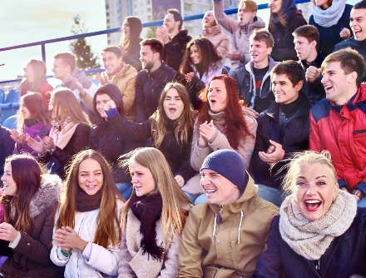
The average crowd at Duckville Dodgers home games increased from 250 in 2016 to 325 in 2017.
What was the percentage increase?

The cost of a plane ticket is $240.00 before 10% GST is added.
What is the price when the GST is included?

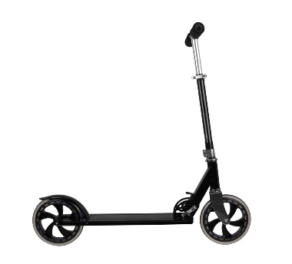
Theo bought a scooter for $375.00 and later sold it for $420.00.
What percentage profit did he make on the cost price?

9.2% 12.0%
17.5% 22.5%
Jason sold his old laptop for $600 which has a 20% loss on the cost price.
What was the cost price?

$480 $620 $720 $750
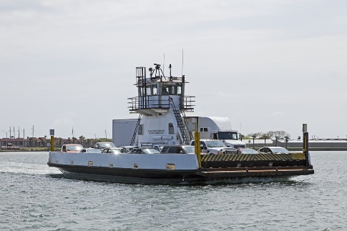
A car ferry can hold 20 cars, but on a trip, it only had 16 cars on board.
What percentage of the car spaces were free?

A 250 g tub of butter costs $6.50 and a 200 g tub costs $5.50.
What is the cost per kilogram of each tub, and which is the better value?

……………………………………………………………………………….…..

…………………………………………………………………………………..

…………………………………………………………………………………..
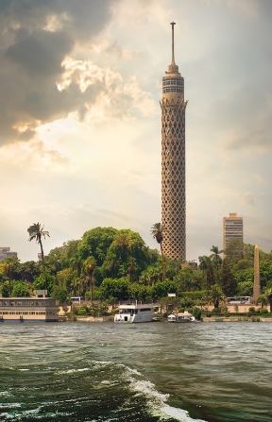
Katherine climbs 45 metres up a vertical tower.
If this was 30% of the total height of the tower, how far is she from the top of the tower?

School Name
Mathematics Test 2017
Year 8 |  | Percentages and Financial Maths | Calculator Allowed  Short Answer  Section
 |  |  | Name___________________
Answer all questions in the spaces provided on this test paper by:
Writing the answer in the box provided.
or
Shading in the bubble for the correct answer from the four choices provided.
Show any working out on this test paper. Calculators are allowed.
What fraction is the same as 0.72?

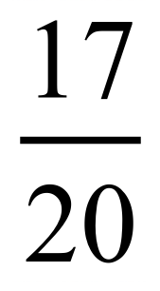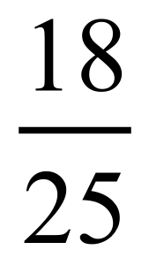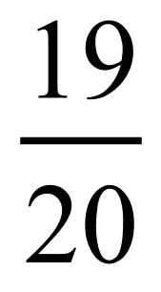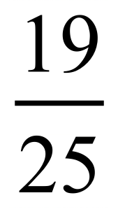

Rebecca has tried 15 out of the 25 dishes on the menu at her favourite café.
What percentage of the dishes is this?

 | What is 0.555 when it is written as a percentage?

In a movie theatre, 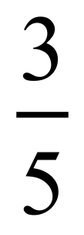 of the audience is aged under 16.
What percentage of the audience is aged 16 or more?

A store takes delivery of T shirts which are in 3 colours.
The owner sees that 25% of them are blue, 33% are white and the rest are black.
What percentage are black?

42% 52%
67% 75%
What is 57% of $ 5200?

$ .
 | 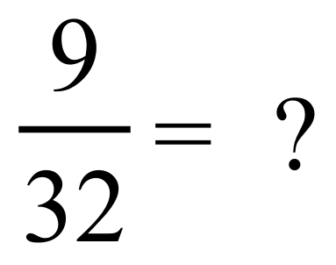


473 489 493 503
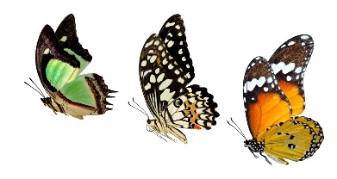
Matty has taken 175 photographs of insects of which 36% are of butterflies?
How many photos of butterflies are there?
63 photos 70 photos
77 photos 84 photos
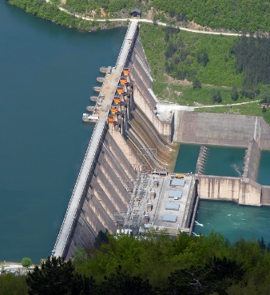
A water storage dam has a capacity of 24.0 gigalitres and currently holds 14.4 gigalitres.
What percentage of its capacity does it currently hold?
54% 56%
60% 64%

 | Increase 450 by 26%.
A school buys a maths resource for $638.00 including GST.
The school can then claim the GST back from the government.
How much could they claim back?

A commercial television channel screens advertising for 15% of the broadcast time, and station promotions for 2.5%, the remaining time being for programs.
Anita was watching the channel and timed 48 minutes of advertising.
How many minutes of programs should she have seen while watching for this period?

Francis pays a $680 accommodation bill with his credit card and is charged a 2.5% surcharge.
He is then charged interest by his bank which comes to 1.5% of the amount he owes.
How much did he pay in total for the accommodation?

Write the following in order from smallest to largest.

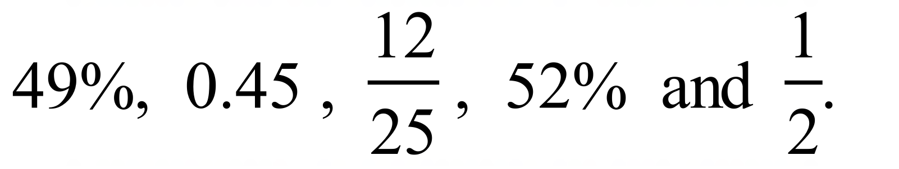

School Name
Mathematics Test 2017
Year 8 | Percentages and Financial Maths | Calculator Allowed  Longer Answer  Section
 |  | Name___________________
Write all working and answers in the spaces provided on this test paper.
Marks may not be awarded if working out and/or answers are not clear.
Marks allocated are shown beside each question.
Calculators are allowed.

 |  | Marks
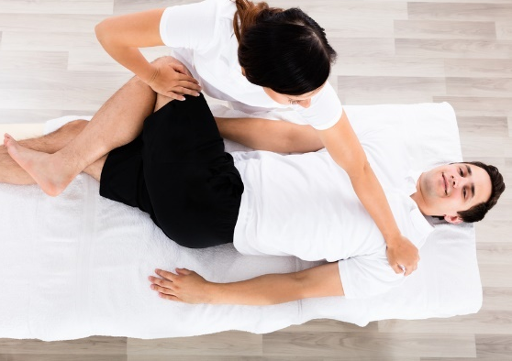
Tony wants to get a half-hour therapeutic massage after playing football. He checks three local providers and finds the following rates:
Active Massage : $2.45 per minute for up to 40 minutes.
Sports Massage : $12.00 per 5 minute block.
Dynamic Massage : $25 per 10 minutes with a 5% discount for massages longer than twenty minutes.

 | (a) What is the cost of a half-hour therapeutic massage from Active Massage?  ……………………………………………………………………………………..  …………………………………………………………………………………….. | 1
 | (b) What is the cost of a half-hour therapeutic massage from Sports Massage?  ……………………………………………………………………………………..  …………………………………………………………………………………….. | 1
 | (c) What is the cost of a half-hour therapeutic massage from Dynamic Massage?  ……………………………………………………………………………………..  …………………………………………………………………………………….. | 1
 | (d) Which provider provides the best value for the half-hour massage, and should this determine which provider he chooses?  ……………………………………………………………………………………..  …………………………………………………………………………………….. | 1
The cash price of a car from Mammoth Motors is $45 600 plus stamp duty which is 5% of the cash price plus registration fees of $850.
The car can also be bought (including stamp duty and registration) by paying monthly instalments of $1036.00 for 5 years.
 | (a) What would it cost in total to buy the car for cash?  ……………………………………………………………………………………..  …………………………………………………………………………………….. | 1
 | (b) What would it cost to buy the car by instalments?  ……………………………………………………………………………………..  …………………………………………………………………………………….. | 1
 | (c) What rate of simple interest is charged per annum for buying on instalments?  ……………………………………………………………………………………..  ……………………………………………………………………………………..  ……………………………………………………………………………………..  …………………………………………………………………………………….. | 2

School Name
Mathematics Test 2017
Year 8 | Percentages and Financial Maths | Non Calculator Section
ANSWERS

Question | Working and Answer
 | 18.5% = 0.185
 | 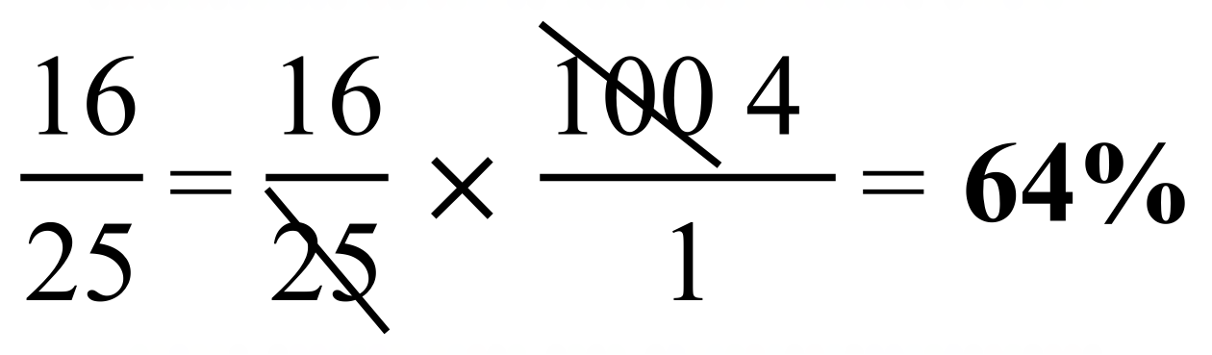
 | 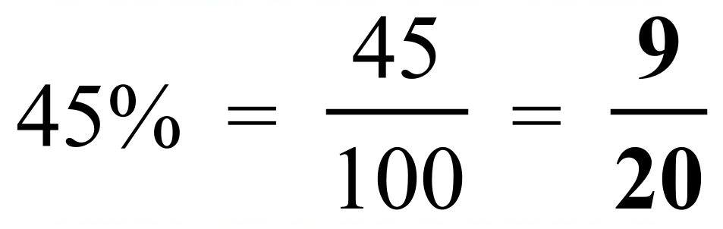
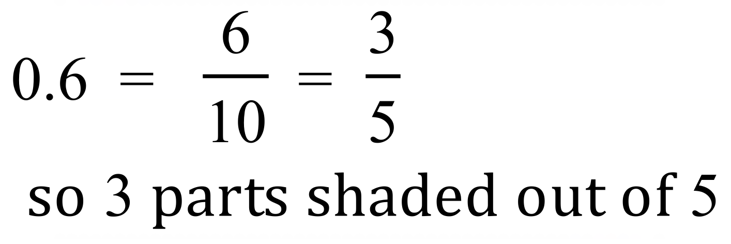
2nd Answer
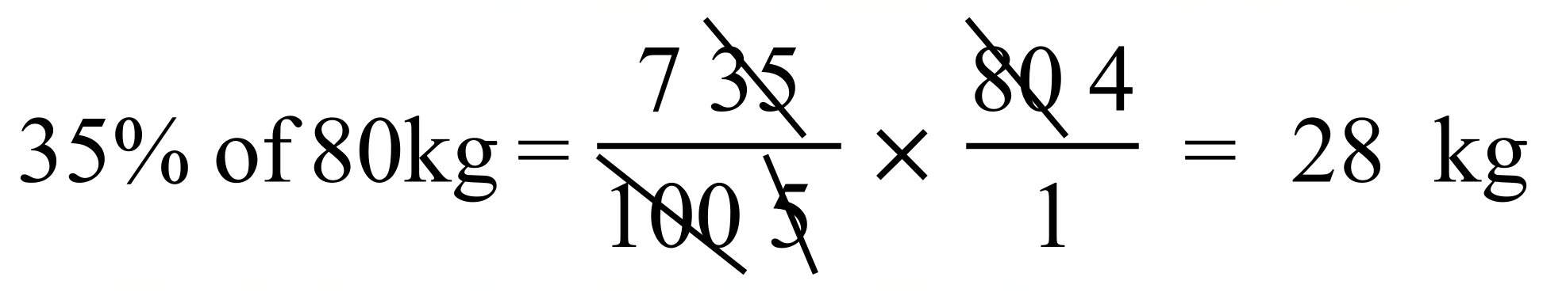
1st Answer
 | 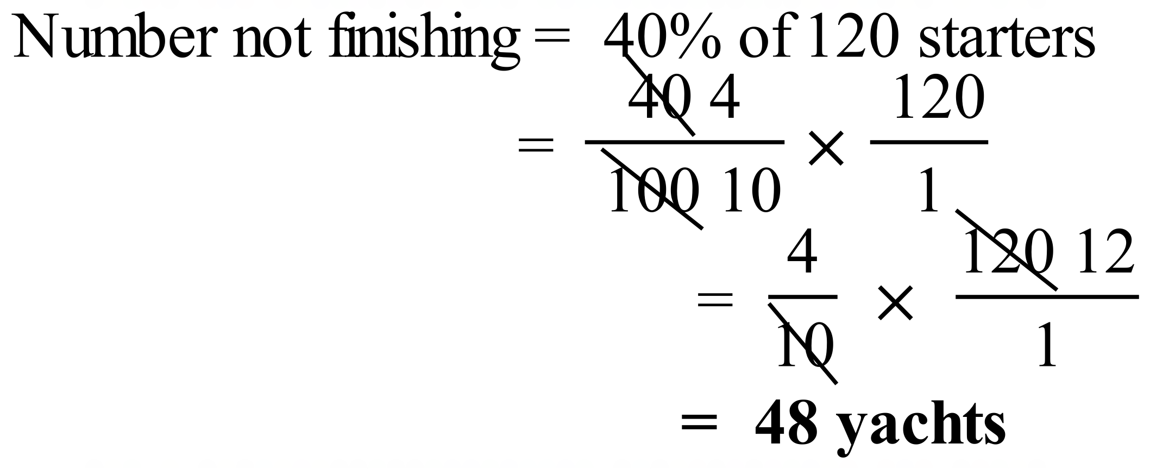
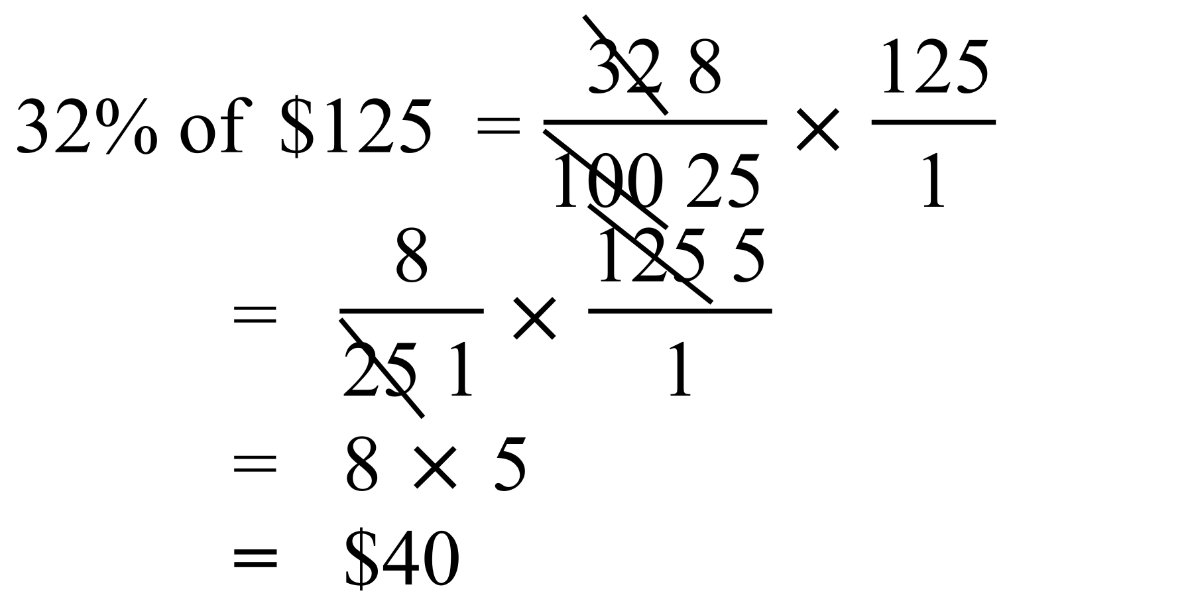
3rd Answer
 | 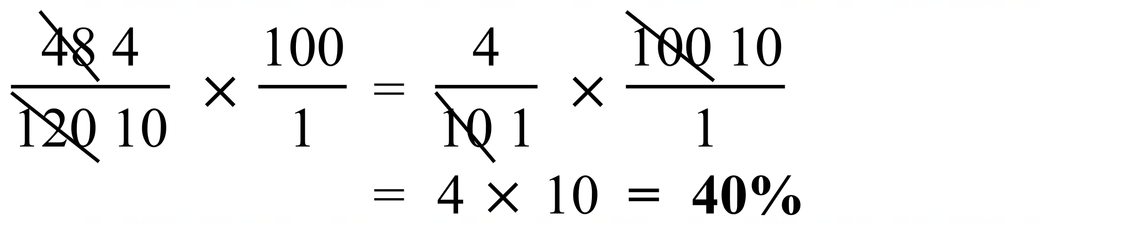
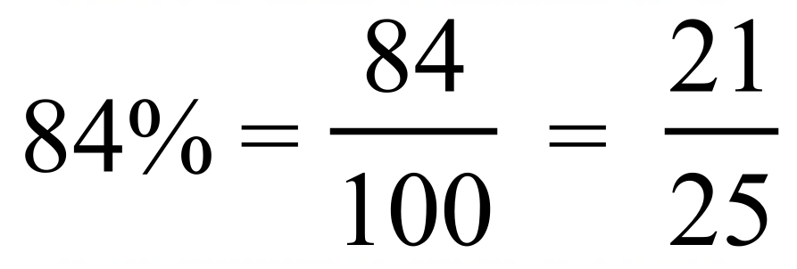
4th Answer
Hammers, wrenches and spanners make up 7.5 + 10 + 45 = 62.5% of total.
This leaves 100% - 62.5% = 37.5% which are screwdrivers.
1st Answer
Increase = 325 – 250 = 75 people
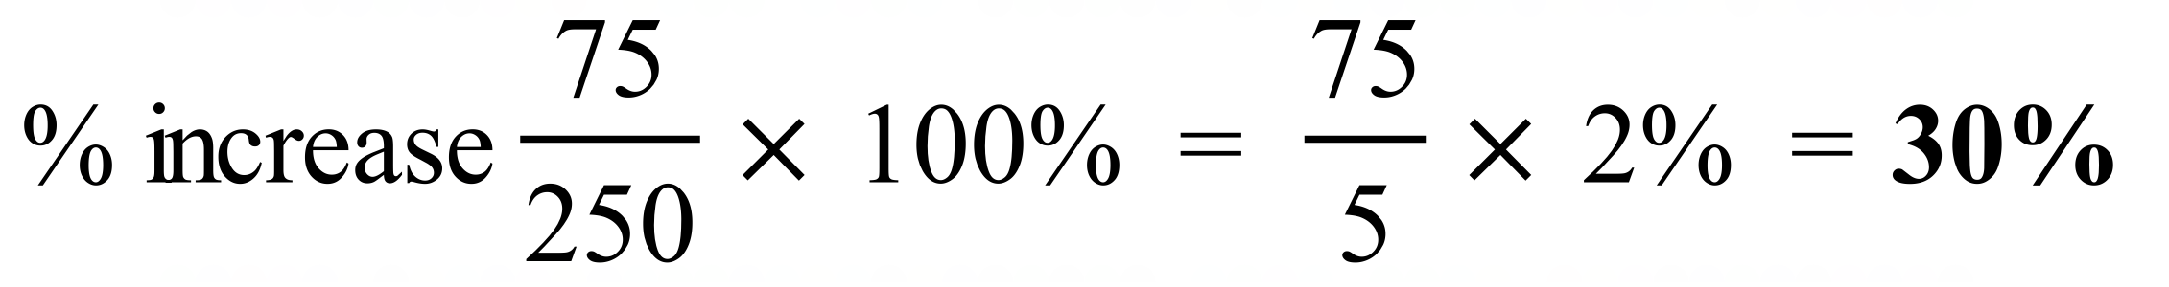
 | 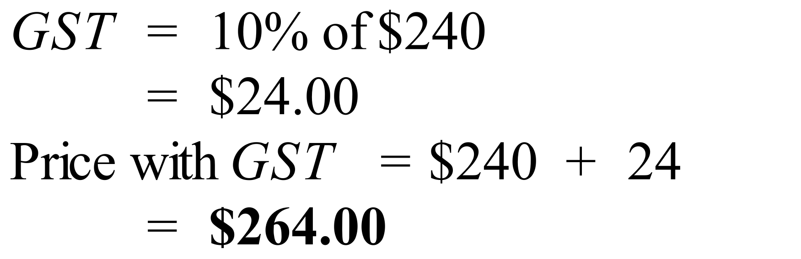
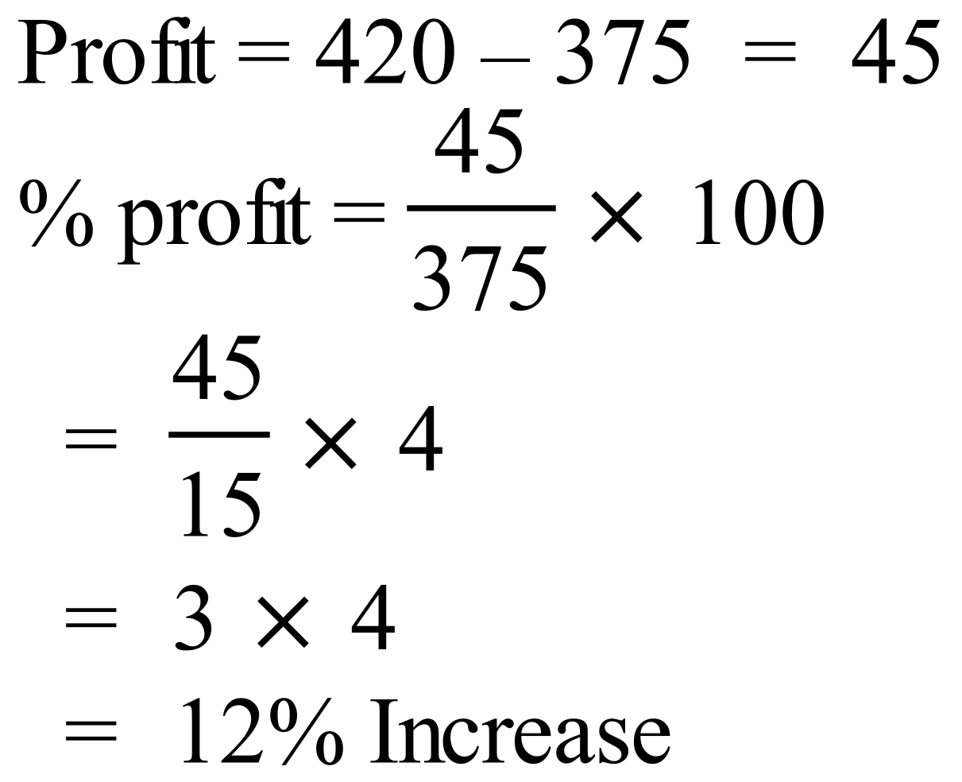
2nd Answer
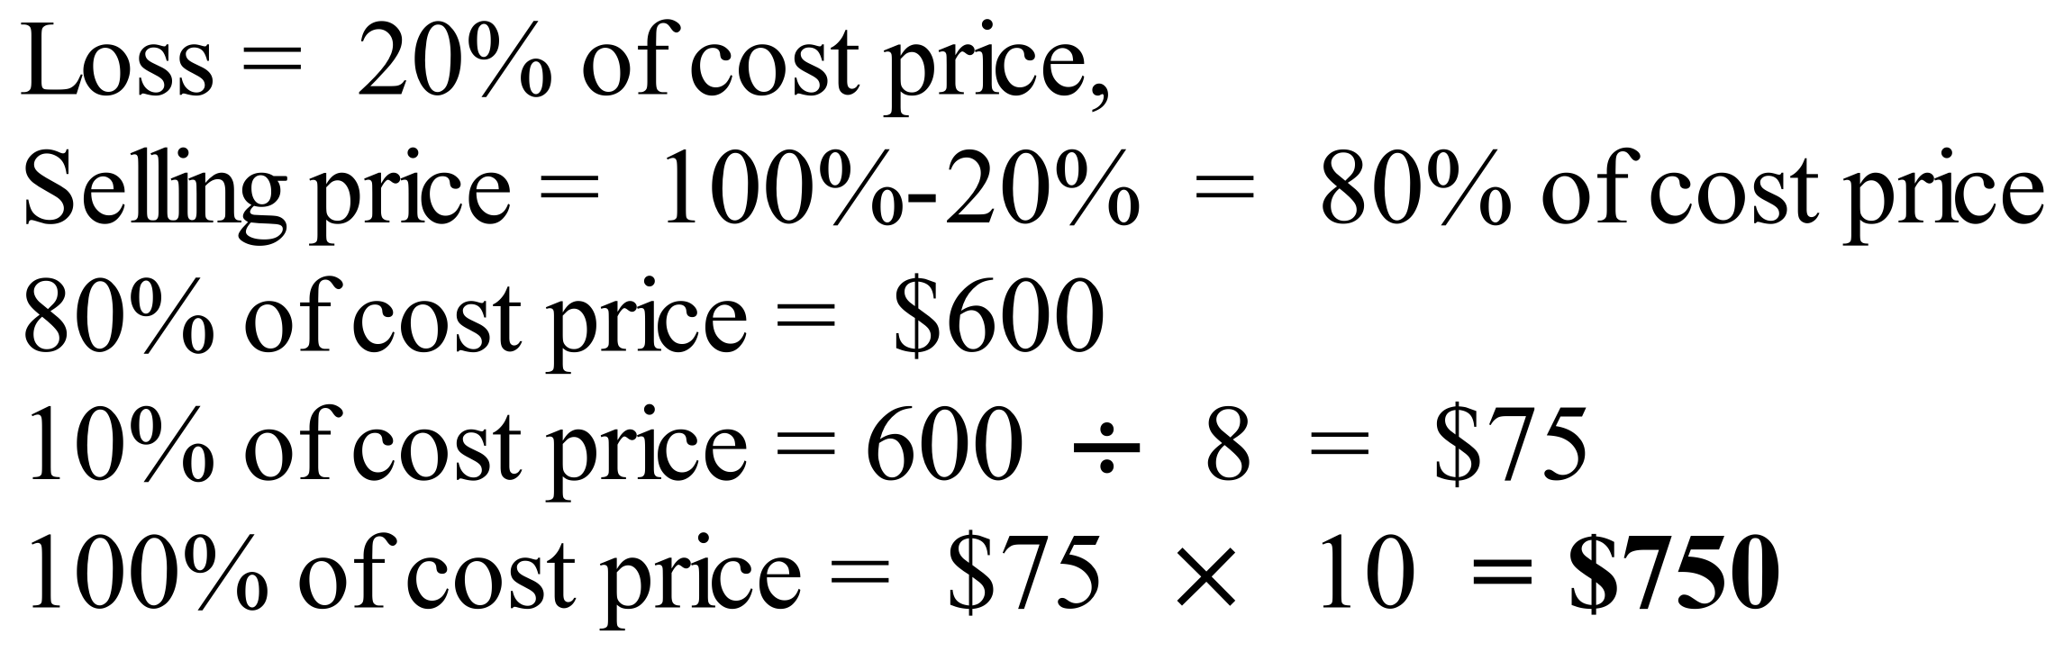
4th Answer
 | 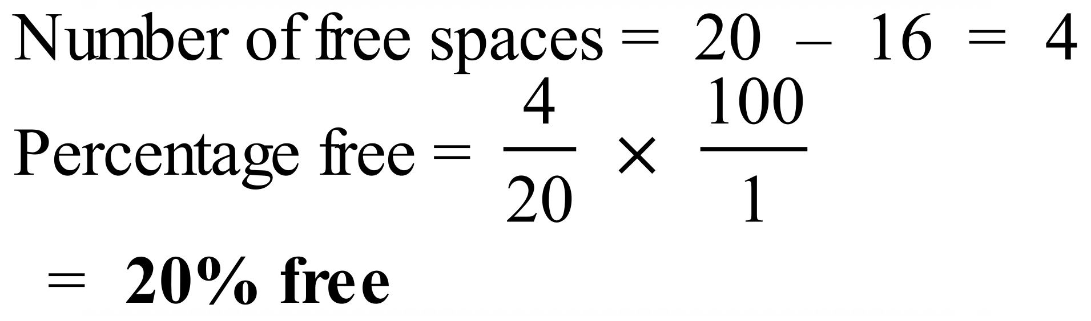
 | 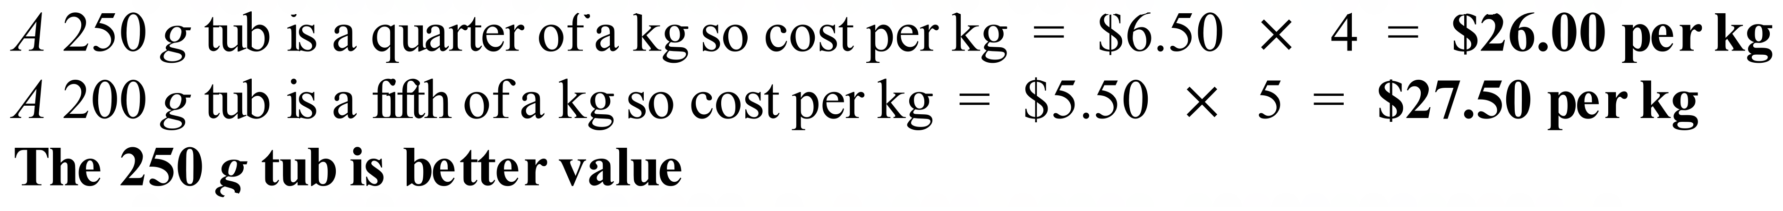
 | 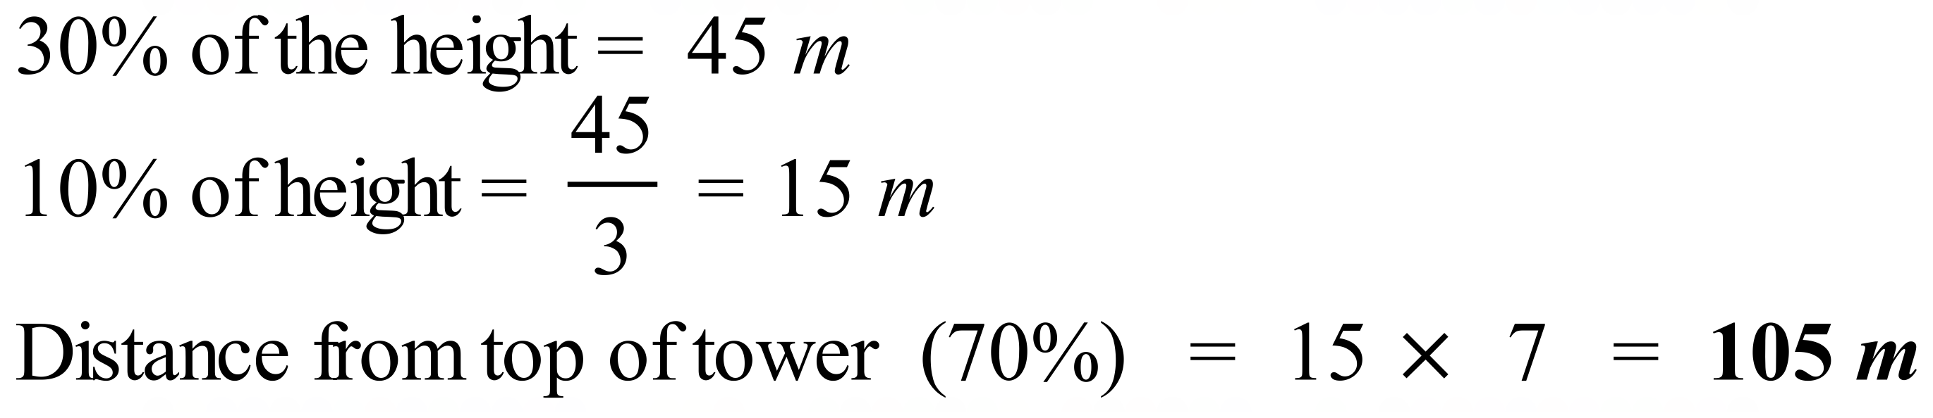

School Name
Mathematics Test 2017
Year 8 | Percentages and Financial Maths | Calculator Allowed  Short Answer  Section

ANSWERS
Question | Working and Answer
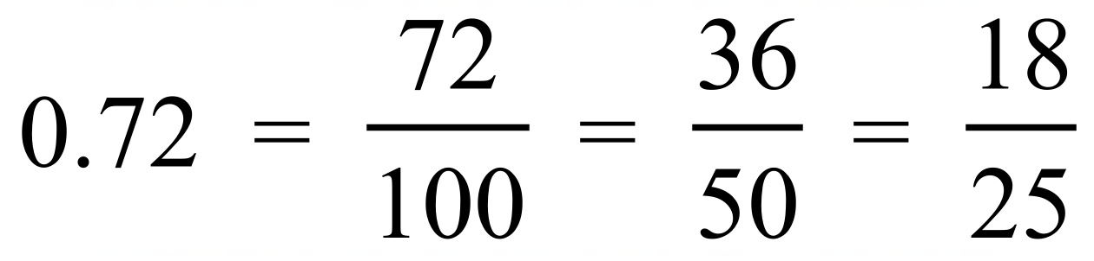
2nd Answer
 | 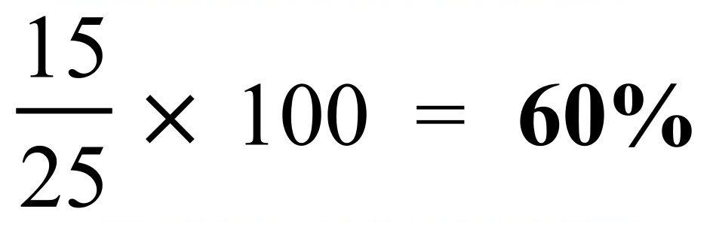
 | 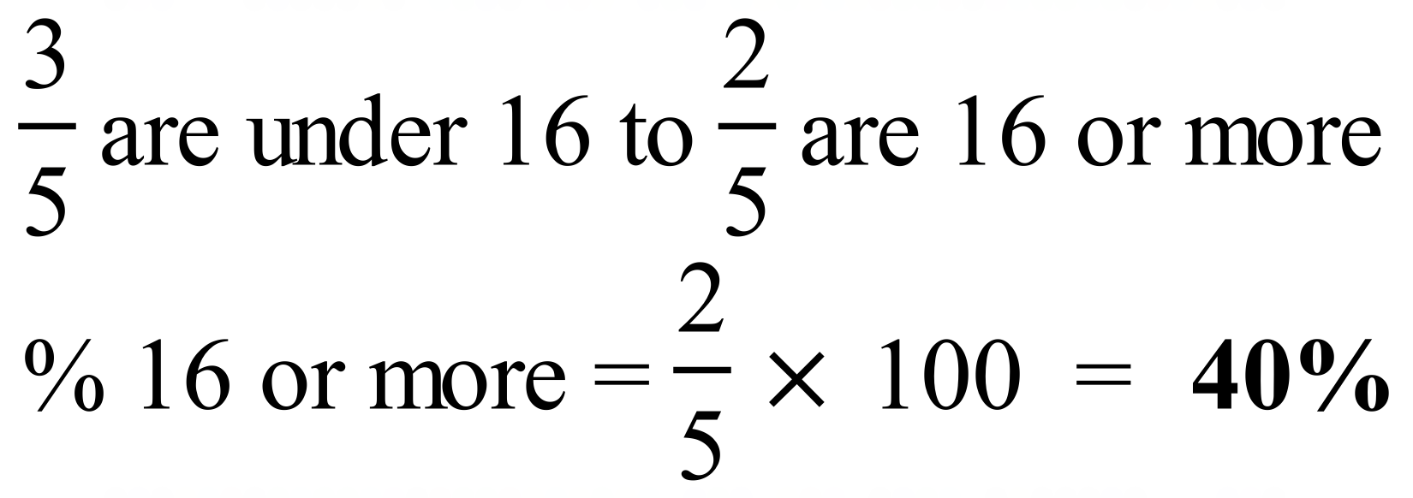
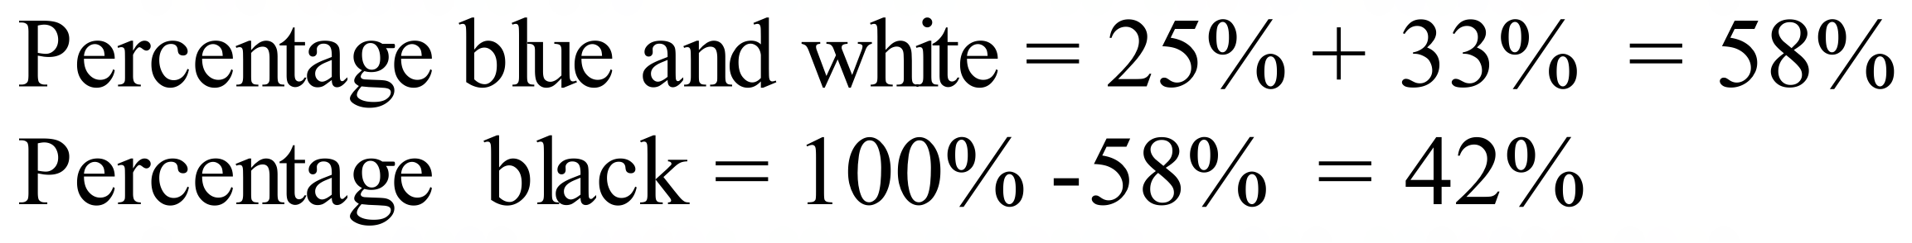
1st Answer
 | 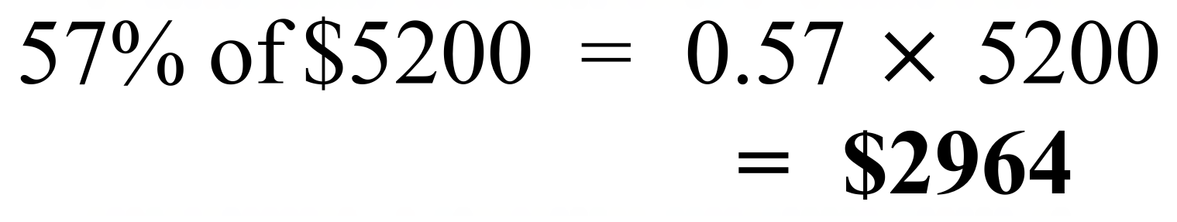
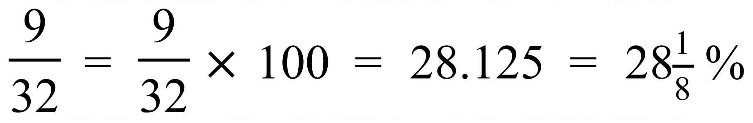
4th Answer
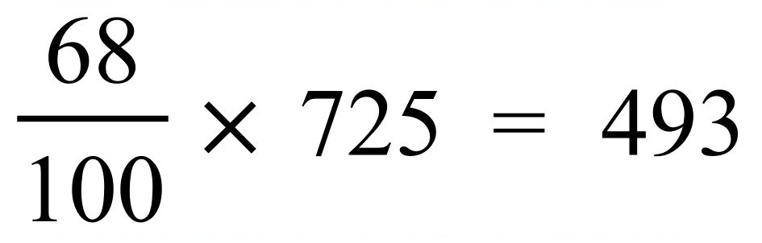
3rd Answer
 | 1st Answer
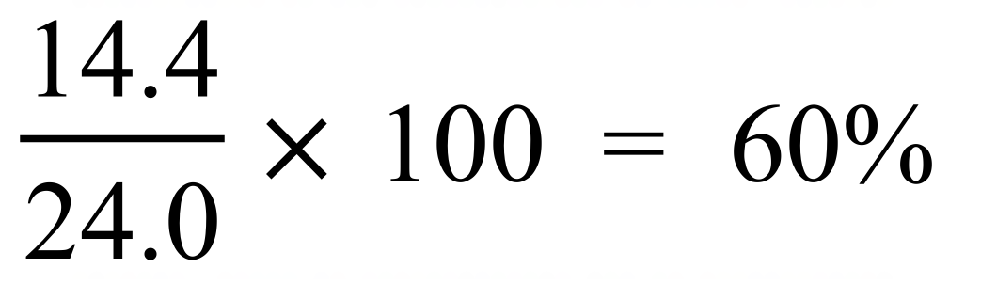
3rd Answer
 | 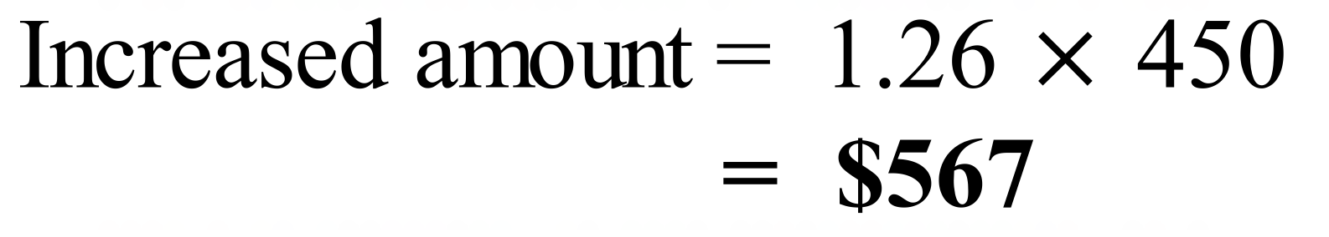
 | 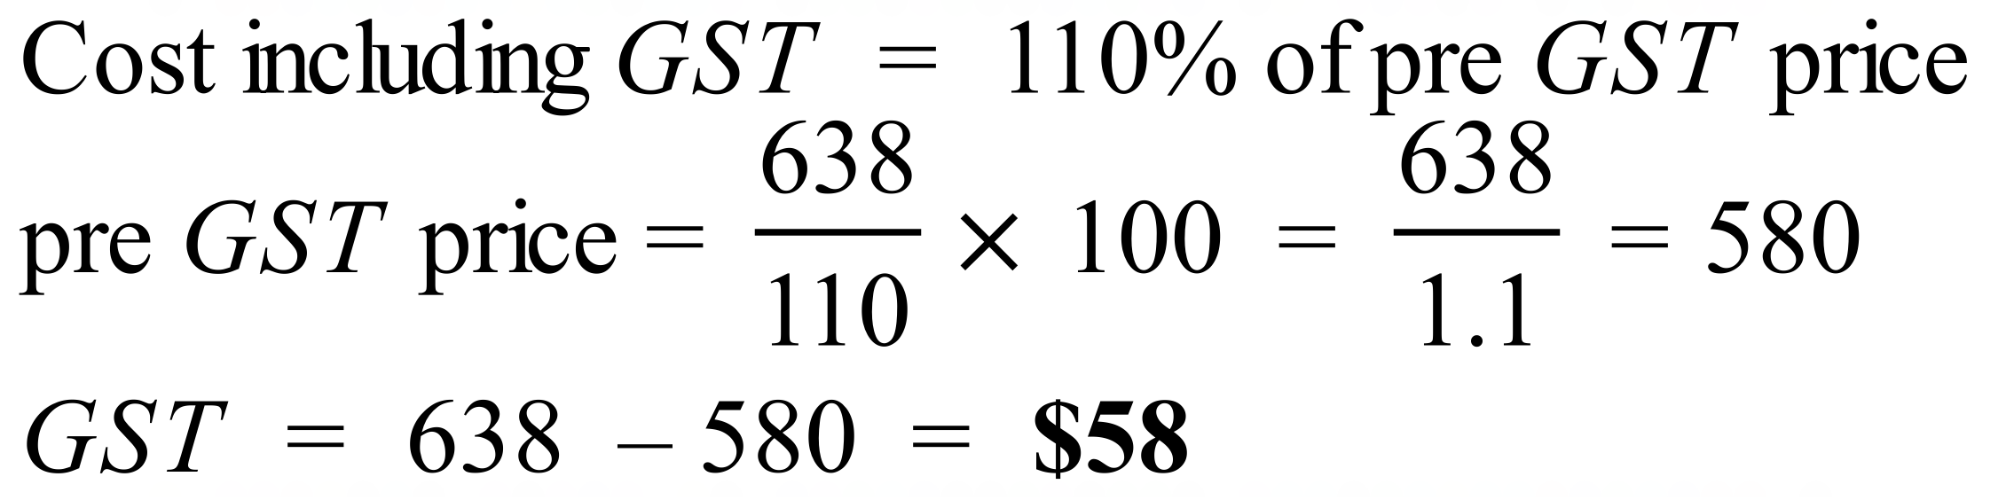
 | 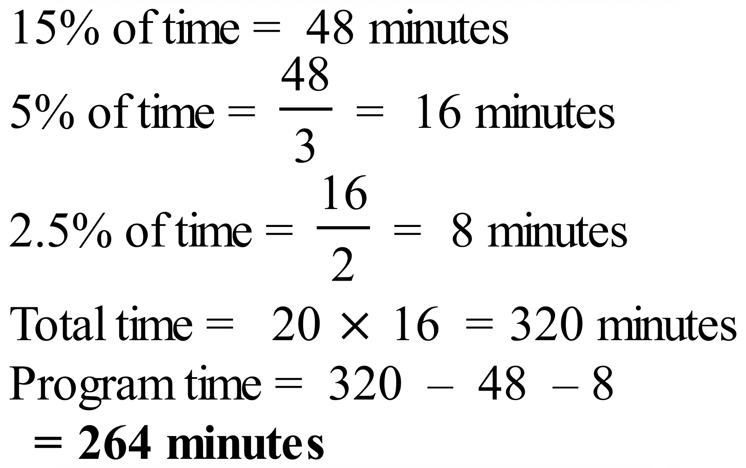
 | 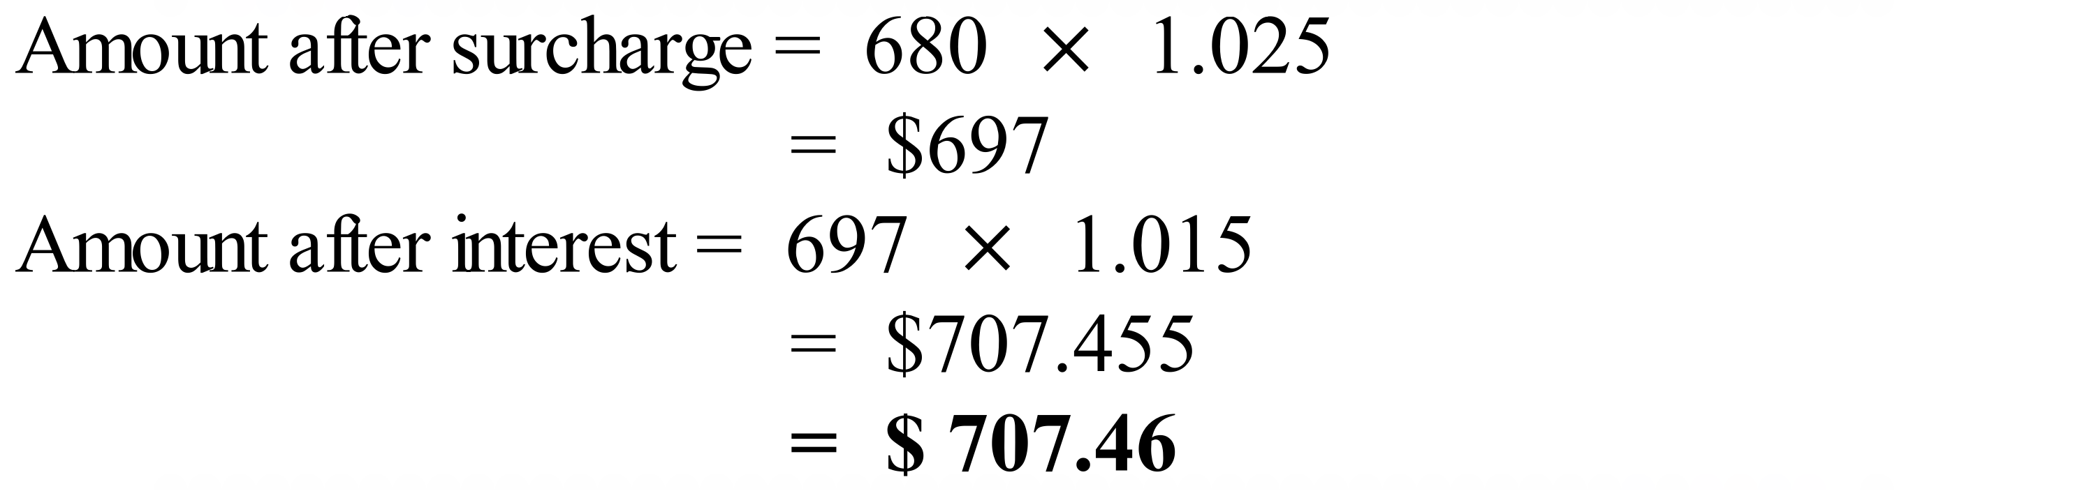
 | 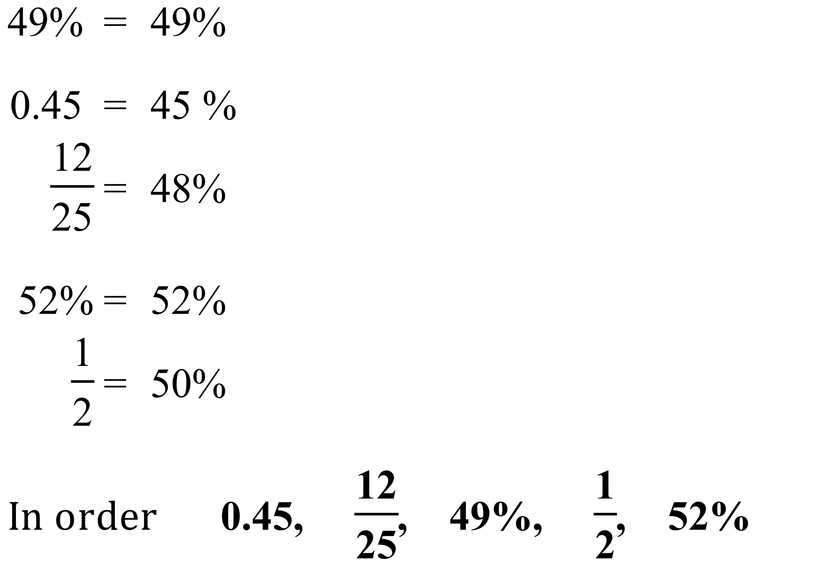

School Name
Mathematics Test 2017
Year 8 | Percentages and Financial Maths | Calculator Allowed  Longer Answer  Section
ANSWERS
Question | Working and Answer | Marks
1. | (a) 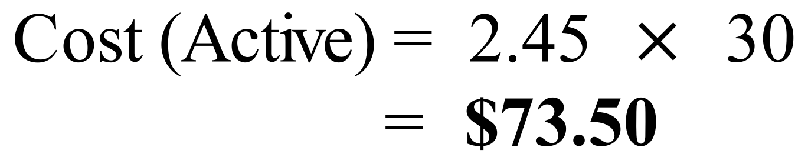 | 1 mark
 | (b) 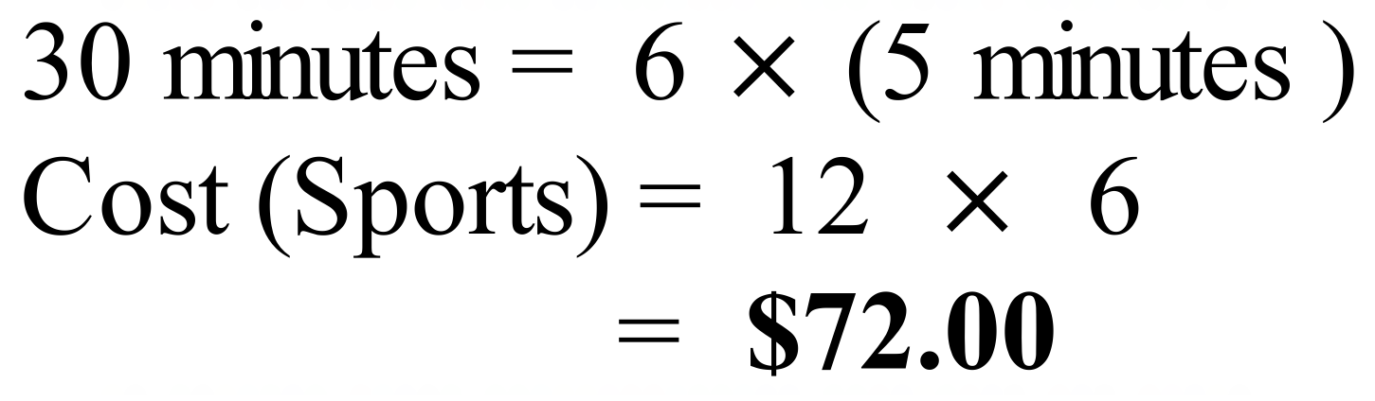 | 1 mark
 | (c) 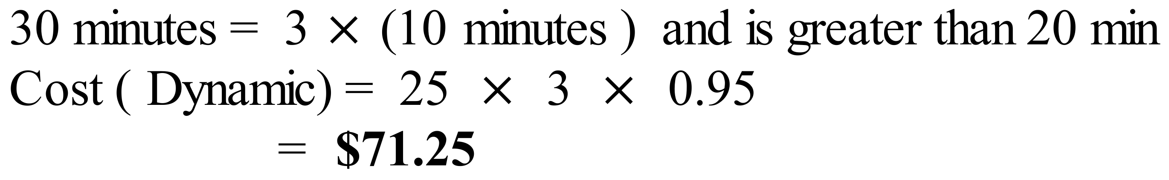 | 1 mark
 | (d) The best value is the Dynamic Massage but is only by 75 cents, so he should also consider other factors such as the reputation of the provider, reviews of their service etc. | 1 mark
2. | (a) 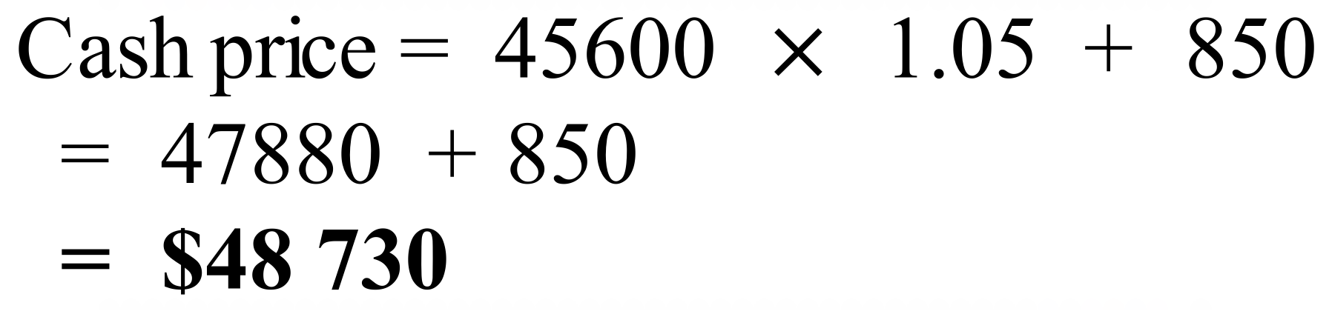 | 1 mark
 | (b) 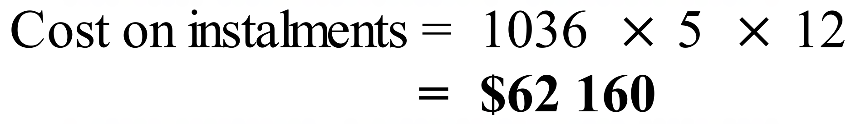 | 1 mark
 | (c) 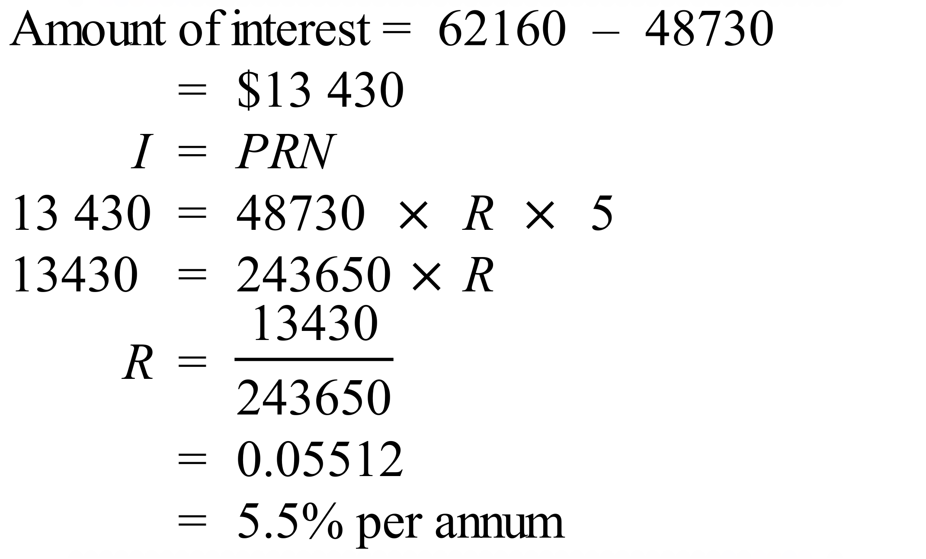 | 2 marks  1 mark for amount of interest  1 mark for percentage rate.

